Quercus spp

Botanical Origin.—Quercus robur L. (Engl. – Common Oak, Pedunculate Oak, English Oak; Ukr. – Дуб звичайний, дуб черешчатий; Rus. – Дуб черешчатый), Quercus petraea (Matt.) Liebl. (Engl. – Durmast Oak; Ukr. – Дуб скельний; Rus. – Дуб скальный). Family – Fagaceae.
Part Used.—Cortex Quercus consists of cut and dried bark from the fresh young branches of Quercus robur L. and Q. petraea (Matt.) Liebl., Fagaceae.
Habitat.—Quercus robur L. is widespread in Europe, Asia Minor and the Caucasus region.

Plant.—The tree is about 50 m high with a broad, irregular, heavily branched crown and a trunk which divides into gnarled, strong, bent branches. The bark is deeply fissured, thick and grey-brown; with 3- to 9- but usually 7- ascending, round-ended lobes, which are separated by deep round-based sinuses. The leaves are short petioled, almost sessile, oblong-obovate, almost lobed, usually cordate or polled at the base. The flowers are reddish brown and monoecious. The male flowers consist of a 5- part perigone with 6 to 10 stamens that appear in small groups in limp, hanging catkins. The female flowers, solitary or in groups of up to 5, appear in a involucre which clasps the base of the fruit and which later becomes bowl-shaped. The yellow staminate flowers open in May when the leaves are partly developed and are found on hairy aments. The pistillate flowers occur on short axillary stalks with hairy, involucral scales and possess red spreading styles. The fruit is an acorn with ovoid, shining glans, it is solitary or in groups of up to 5 on 1 shared, glabrous or occasionally sparsely pubescent stem. They are oblong ovate, acuminate and enclosed in the bowl-shaped cupule.
MPM Description.—According to the EP, The bark occurs in channelled or quilled pieces, not more than 3 mm thick. The outer surface is light grey or greenish-grey, rather smooth, with occasional lenticels. The inner surface is dull brown or reddish-brown and has slightly raised longitudinal striations about 0.5 mm to 1 mm wide. The fracture is splintery and fibrous.
Odour faint; taste strongly astringent, not tingeing the saliva yellow when chewed.

Microscopical Characters.—Passing from outer to inner surface, the following peculiarities are evident:
1. Cork of 5 to 25 layers of suberous cells. These layers ultimately become differentiated into alternating zones of suberized-walled and lignified-walled cells.
2. Several layers of collenchyma cells.
3. Cortex of a varying number of layers of cortical parenchyma cells containing rosette crystals of CaC₂O₄, a zone of mechanical cells, a brownish-yellow amorphous substance or chloroplasts. Secondary bark is rich in mechanical cells.
4. Pericycle. Sclerenchyma fibers with lamellated walls.
5. Phloem, a broad region composed of phloem patches separated by starch-containing medullary rays, 1-2 cells wide. Most of the elements of the phloem patches are sieve tubes and phloem cells. Stone cells and bast fibers may occur sparingly in this region but are not seen in every section. The phloem cells may contain either starch, rosettes of CaC₂O₄ or a reddish-brown amorphous substance. The starch grains are either simple or compound, the individual grains being usually 2-6 mkm in diameter.
As the bark becomes older, secondary phellogens arise in cortex, pericycle and outer phloem causing a sloughing off of the primary bark tissues. These exfoliating tissues often adhere for long periods to the inner tissues forming bark in which sclerenchyma elements may be found imbedded in necrosed parenchyma.
Powdered Drug.—According to the EP, The powder shows groups of thick-walled fibres surrounded by a moderately thickened parenchymatous sheath containing prism crystals of calcium oxalate; fragments of cork composed of thin-walled tabular cells filled with brownish or reddish contents; abundant sclereids, isolated and in groups, some large with thick, stratified walls and branching pits, others smaller and thinner-walled with simple pits, often with dense brown contents; fragments of parenchyma containing cluster crystals of calcium oxalate; occasional fragments of sieve tissue, thin-walled, some showing sieve areas on the oblique end-walls.
Constituents.—Condensed tannins (12%), gallic and ellagic acids, catechin tannins (oligomeric proanthocyanidins), ellagitannins, gallotannins, monomeric and dimeric catechins and leucocyanidins; saponins; hydrocarbons.
Pharmacological Action. Uses.—The drug is astringent, antiphlogistic, antiviral and anthelmintic. Decoction is used externally as an astrigent and anti-inflammatory agent in guinguitis and stomatitis, burns and freezings. Oak bark is an ingredient of antihaemorrhoidal herbal collections. Approved by Commission E indications comprise cough and bronchitis, diarrhea, inflammation of the mouth and pharynx, inflammation of the skin.

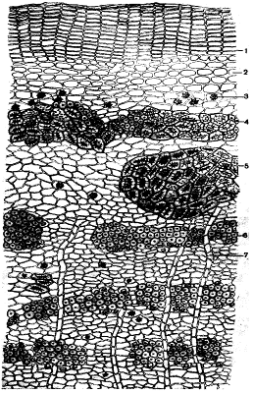
Fig. Cross-section of Quercus robur bark. 1–Cork 2–collenchyma 3–aggregate crystal of CaC₂O₄ 4–mechanical,tissue 5–stone,cells 6 – bast fibers with crystals of CaC₂O₄ 7 – medullary rays

Potentilla erecta

Botanical Origin.—Potentilla erecta (L.) Rausch.(Potentilla tormentillaStokes) (Engl. – Tormentil, Cinquefoil; Ukr. – Перстач прямостоячий, калган; Rus. – Лапчатка прямостоячая, калган). Family –Rosaceae.
Part Used.—Rhizomata Tormentillae consist of whole or cut, dried rhizome, freed from the roots, of Potentilla erecta (L.) Raeusch. (P tormentilla Stokes), Rosaceae.
Habitat.—The plant is found as far north as Northern Scandinavia and as far south as Northwest Africa, Italy, Central Spain and the Balkans.
Plant.—The plant is about 30 cm high and a rhizomatus herbacious perennial. The rhizome is 1 to 3 cm thick, irregular, tough, gnarled to cylindrical, woody, dark-brown outside and blood red inside, with numerous radicles. The stem is erect or decumbent, never rooting, branching. The trifoliate rosette-like basal leaves wilt early and are gone before flowering. The cauline leaves are sessile, trifoliate, acute, deeply serrated, somewhat hairy and appear to be in fives because of 2 stipules. The stipules are smaller than the leaflets, and deeply cut. The small, yellow, long-pedicled flowers grow opposite the leaves or at branching points on the stem. The flowers are borne on slender, axillary, hairy stalks much longer than the leaves. Carpels corrugated when ripe. The 4 sepals have a 4-bract epicalyx. There are 4 free petals, which are obcordate and somewhat darker at the base. There are usually 16 stamens and numerous ovaries with threadlike styles. The receptacle is domed. The fruit is nut-like hard, 1 seeded, ovate, grooved and occasionally smooth.

MPM Description.—According to the EP, The rhizome is cylindrically spindle-shaped, with a very irregular appearance, often forming, twisted, knotty tubers, up to 10 cm long and 1 cm to 2 cm thick, very hard and scarcely branched. The surface is brown to reddish-brown, rugose and has remains of roots and transversely elongated depressed whitish scars from the stems. At the top of the rhizome the remains of numerous aerial stems may be present. The fracture is short and granular, dark red to brownish-yellow.
Microscopic Characters.—According to the EP, coarsely serrate cluster crystals of calcium oxalate, up to 60 μm in diameter; fragments of thin-walled parenchyma containing reddish-brown tannin; groups of narrow, bordered-pitted vessels with lateral pores; thick-walled and pitted, polygonal parenchyma; groups and fragments of sclerenchymatous thick-walled fibres; occasional fragments of cork with thin-walled, brown, tabular cells. The powder shows spherical or elliptical starch granules, up to about 20 μm in length.
Constituents.—Tannins (17 to 22%): catechin tannins (15 to 20%), transformed under storage conditions into non-water soluble tanner's reds (phlobaphenes), gallotannins (3.5%): agrimonine, pedunculagin, levigatines B and F proanthocyanidins; ellagic acid; catechins: including (-)-gallocatechin gallate, (-)-epigallocatechin gallate, dimerics and trimerics of the catechin derivatives; flavonoid kaempferol; triterpenoid saponins (tormentoside, ursolic acid); volatile oil; gums; resins.
It contains, according to the EP, minimum 7 per cent of tannins, expressed as pyrogallol (dried drug).
Pharmacological Action. Uses.—Tormentil is astringent, and may be used in enteritis, enterocolitis, acute and chronic diarrhea, uterine and haemorrhoidal haemorrhages, inflammation of the mouth and pharynx and as a local application in stomatitis and gingivitis.

Fig. Scheme of a cross section of Rhizoma Tormentillae. 1 – cork; 2- sieve tubes; 3 - cambium; 4 - xylem; 5 - sclerenchymatous thick-walled fibres.
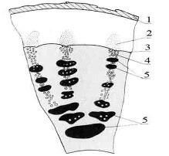
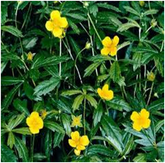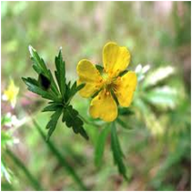

Rhus coriaria

Botanical Origin.—Rhus coriaria L. (Engl. – Elm – leaved Sumach, Sicilian Sumach; Ukr. – Сумах дубильний; Rus. – Сумах дубильный). Family – Anacardiaceae.
Part Used.—Folia Rhois coriariae consist of the dried leaves of Rhus coriaria L., Anacardiaceae.
Habitat.—Europe, southern Ukraine.
Plant.—Varies from a shrub to rarely a tree, growing to the height of 2 to 3 m. The bark of the trunk is dark yellow or grey. Leaves are alternate, pinnate, smooth, entire or slightly sinuate, imparipinnate with from 7 to 21 lanceolate or oblong-lanceolate leaflets, and an odd terminal one. Each leaflet is acuminate at the summit, rounded or oblique at the base and sharply serrate along the margin. Flowers are polygamous, very small, greenish - white, and in loose or slender axillary panicles (erect terminal thyrses). The drupes are small, globose, red, pubescent.
Constituens. —Tannins : gallotannin, gallic acid and its methyl esters (totally 13-25%); flavonoids (myrecitin); ascorbic acid.
MPM Description.—Leaves are pinnate, smooth, entire or slightly sinuate, lanceolate or oblong-lanceolate. Each leaflet is acuminate at the summit, rounded or oblique at the base and sharply serrate along the margin.
Pharmacological Action. Uses.—The MPM is a source for obtaining of tannin that is used as a component of Galascorbinum and Liquoris Novicovi.

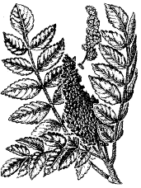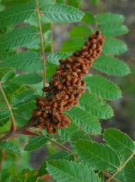

Alnus spp

Botanical Origin.—Alnus incana (L.) Moench. (Engl. – Grey Alder, Black Alder; Ukr. – Вільха сіра; Rus. – Ольха серая), Alnus glutinosa (L.) Gaertn. (Engl. – Black Alder, European Alder; Ukr. – Вільха клейка; Rus. – Ольха клейкая). Family – Betulaceae.
Part Used.—Fructus Alni consist of the dried fruits Alnus incana (L.) Moench. and/or Alnus glutinosa (L.) Gaertn., Betulaceae.
Habitat.—Black Alder originated in the damp regions of Europe, Asia and North America. The plant now grows in much of the Northern Hemisphere.
Plants.—Alnus incana (L.) Moench. grows as a shrub or tree extending up to 25 m high, a trunk 0, 3 m in diameter. Black Alder has gray smooth branches and orange-coloured wood. The twigs glabrous, the young shoots pubescent. The obovate dark green leaves, with the teeth serrulate, obtuse or some of them acute at the base, dark green above, pale or glaucous and pubescent, at least on the veins beneath, the veins prominent on the lower surface; the young leaves are very sticky. Black Alder is monoecious. Male flowers are arranged in stemmed catkins. Female flowers form ovoid fruit, which turns woody and remains on the tree the whole year. Stipules oblong-lanceolate, deciduous; aments unfolding much before the leaves, the pistillate ovoid in one celled nut fruit, their bracts 5-toothed, nut orbicular, coriaceous-margined.
Alnus glutinosa (L.) Gaertn. Shrub or small tree to 10 m, the speckled bark initially gray-brown, smooth, lustrous, later dark gray and rougher. Double toothed leaves alternate, rotund or broadly ovate to ellipsoid or ovate, whitish underneath, basally rounded the petiole; stipules obtuse, secondary veins connect to primary veins. Flowers monoecious (separate male and female flowers on the same plant). Male cones purplish brown. Fruits rounded, the seeds winged. Small brown winged nutlet seeds are borne in green ovoid rough fruits. Twigs green-brown to brown and smooth.
MPM Description.—One celled orbicular nut fruit, its bracts 5-toothed, coriaceous-margined, the seeds winged. Small brown winged nutlet seeds are borne in green ovoid rough fruits. Twigs green-brown to brown and smooth.
Constituents.—Tannins up to 20 % (gallotannin and elagotannin) and gallic acid; flavonoids: in particular hypericin; β - sitosterol; triterpenes.
Pharmacological Action. Uses.—The decoction is a tonic and has astringent, anti-inflammatory and hemostatic properties, which may be due to the tannins (20%), flavone glycosides and triterpenes. Black Alder is used as a decoction for gargles in the treatment of streptococcal sore throat and pharyngitis, and for intestinal bleeding.
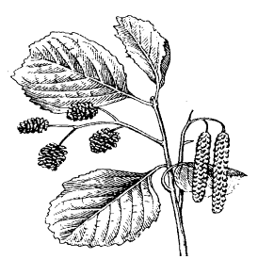
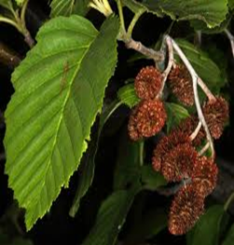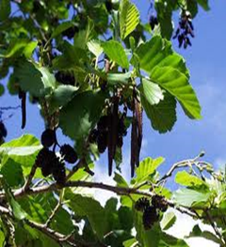

Alnus incana Alnus glutinosa

Vaccinium myrtillus

Botanical Origin.—Vaccinium myrtillus L. (Engl. – Bilberry, Blueberry; Ukr. – Чорниця звичайна; Rus. – Черника обыкновенная). Family – Ericaceae.
Part Used.—Fructus Myrtilli, Folia Myrtilli consist of fruits and/or leaves of Vaccinium myrtillus L., Ericaceae.
Habitat.—The plant is common to central and northern Europe, Asia and North America.
Plant.—The plant is a deciduous, dwarf subshrub with sharp-edged, green branches 15 to 50 cm high. The leaves are alternate, light-green, ovate or oblong-ovate, acuminate and finely serrate. The bell-shaped flowers are axillary and solitary or in pairs at the base of the leaves. They are 4 to 7 mm long, short-pedicled, greenish and tinged with pale pink. The calyx is fused to the ovary, persistent and indistinctly 5-lobed. The corolla is globular-jug-shaped and has 5 tips. There are 8 to 10 stamens, which are enclosed and shorter than the styles. They have glabrous filaments that widen toward the base and 2 horn-like yellow-brown anthers, whose spurred appendage is erect. The fruit is on the flattened top, the remains of the style and the calyx form a small disc with a dull edge. The fruit is a tetra- or pentalocular globular, blue-black, frosted, many-seeded berry with a fleshy mesocarp with purple pulp.
Adulteration.—Rare. The fruits of Vaccinium uliginosum L. (bog bilberry) are rather similar to bilberries bit produce only a faint brownish coloured solution upon aqueous extraction.

Table.Distinguishing diagnostic characters of Vaccinium myrtillus and its adulterants

 | Fruits | Seeds
Vaccinium myrtillus L. | a tetra- or pentalocular subglobular, dark blue, shrunken, many-seeded berry about 5 mm in diameter, with a fleshy mesocarp with purple pulp | numerous, slight half-moon-shaped or similar, lateral compressed, small (1.2-1.4 x 0.6-0.7 mm). Surface longitudinal shallow furrowed, lustrous, dark-brown
Ribes nigrum L. | the berries are globose, glandular punctuate, ranging in diameter from about 7 to 15 mm; epicarp shiny black externally, enclosing a yellowish green translucent pulp containing numerous flattened ovoid seeds | numerous, elliptic-ovate, usually irregular, about 2.5 mm long, 1.25 mm wide and 1 mm thick. Surface dull or slight lustrous, roughen, dark purple-brown to blackbrown or black
Sambucus ebulus L. | a drupe, globose, 4-5 mm in diameter, orange coloured turning black, shiny | 3, stones obovoid, dorsal side convex, ventral rooflike, apex slight roundish, bottom gradually narrowed, with small hilum, 3.2-3.6 x 1.6-1.8 mm. Surface transversal furrowed, smooth, pinkish
Sambucus nigra L. | a black-violet, shiny, berry-like drupe with blood-red juice | 3, stones ellipsoidal or ovate, dorsal side convex, ventral rooflike, apex truncate, bottom gradually narrowed with hilum, 3.5-4.1 x 1.8-2.2 mm. Surface transversal furrowed, pale-brown
Padus racemosa (Lam.) C. K. Schneid. | a drupe, globose, up to 8 mm in diameter, shiny; taste astringent, somewhat acidulous, odour none | 1, stone spherical to broad ovoid, blunt-pointed at the apex, with suture broaden on ventral and narrowed on dorsal side, 6.4-7 x 4.5-5 mm. Surface reticulate strong ridged, rough, light-brown
Frangula alnus Mill. | a drupe, red at first, then black at maturity, shiny, furrowed, 8 – 10 mm in diameter | 2 – 3 stones, broad obovoid, strong dorsoventral flattish, ventral ridge not reaching the apex, base with a large open hilum, 4.5-5 x 4-4.5 mm. Surface smooth, light yellowish-green, base orange
Rhamnus cathartica L. | a berry-like drupe, black, shiny, furrowed, 5 – 8 mm in diameter; odour faint, unpleasant | 3 - 4, rarely 2, stones sectorial, slight lateral flattish, elliptic, base with a small triangular hilum, 5-5.6 x 2.9-3.3 mm. Surface smooth, dull, with ventral ridge, hilum olivebrown

MPM Description.—According to the EP, Dried bilberry is a dark blue, subglobular, shrunken berry about 5 mm in diameter, with a scar at the lower end and surmounted by the persistent calyx, which appears as a circular fold and the remains of the style. The deep violet, fleshy mesocarp contains numerous small, brown, ovoid seeds.
Constituents.—Blueberries are rich in condensed tannins (5-12%, chiefly catechin tannins, including oligomeric procyanidins), organic acids (quinic acid (3-5%), malic acid, citric acid). Phenolic acids (chlorogenic acid) and flavonoids (hyperoside, isoquercitrin, quercitrin, astragaline) and monomeric flavan-3-ols (catechin and epicatechin), pectins and iridoids (asperuloside) have been identified. The anthocyanin level in the fresh fruits is about 0.5%. These glycosides are C-3-0-glucosides, O-galactosides, and O-arabinosides of cyanidin, peonidin, delphinidin, malvidin, and petunidin. The mixture of such glycosides of delphinidin and malvidin is known as mirtyllin.
The bilberry leaf contains condensed tannins (7-20%), phenolic glycosides (neomyrtyllin, myrtyllin, arbutin, the latter up to 1 %), flavonoids (rhamnoglucosyl-, arabinosyl-, and glucuronylquercetin; avicularin, hyperoside isoquercitrin, quercitrin, meratine, astragaline); chlorogenic acid; phenolic acids (salicylic acid, gentisic acid); iridoide monoterpenes (asperuloside, monotropein). It is rich in oligomeric proanthocyanidins and catechin (up to 10%).
Pharmacological Action. Uses.—Fruits and leaves are used as a mild astrigent in child diarrhea and acute enterocolitis of adults. Myrtyllin decreases the blood sugar level. It is thought that the chromium content of the drug is responsible for a possible antidiabetic effect. Folia Myrtilli is included into the herbal collection Arphasetinum. External uses of the leaves include inflammation of the oral mucosa, eye inflammation, burns and skin diseases.
Externally the berry is used for mild inflammation of the mucous membranes of mouth and throat. It is generally accepted that anthocyanins, by facilitating the regeneration of rhodopsin, improve vision in poor light. Extracts obtained from the bilberry fruits and enriched in anthocyanins are ingredients of drugs used to treat the functional symptoms of venous and lymphatic vessel insufficiency, cutaneous capillary fragility, and mesopic and scotopic vision (nyctalopia, myopia).

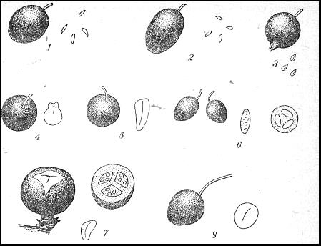

Fig. Black berries, their seeds and stones: 1 - Vaccinium myrtillus, 2 - Vaccinium uliginosum, 3 - Ribes nigrum, 4 - Frangula alnus, 5 - Rhamnus cathartica, 6 - Sambucus nigra, 7 – Juniperus communis, 8 - Padus racemosa
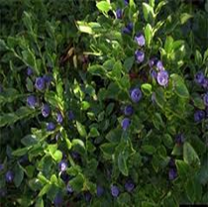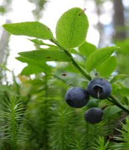
Cotinus coggygria

Botanical Origin.—Cotinus coggygria Scop. (Engl. – Smokebush, Venetian Sumac; Ukr. – Cкумпія звичайна; Rus. – Скумпия кожевенная). Family – Anacardiaceae.
Part Used.—Folia Cotini coggygriae consist of the leaves of Cotinus coggygria Scop., Anacardiaceae.
Habitat.—Europe, southern Ukraine. Plant is cultivated in parks and gardens.
Plant.—A branching shrub or a tree, growing to the height of 3 to 6 m. Stems are glaucous. Leaves are simple, alternate, entire, with long petioles. Each leaf is dark green above, and warm grey beneath. Their colour changes to red in autumn. Flowers are small, white-greenish and arranged in large branchy terminal panicles.
Microscopical characters.—Cells of upper and lower epidermises with straight walls, stomata are present in lower epidermis. Stomatal apparatus consist of 4-6 neighbouring cells. Non-glandular and glandular hairs occur on the lower epidermis. Non-glandular hairs with 1 or 3-5 cells, have reinforced, warty walls. Glandular hairs with a 1-celled stalk and 3-celled head containing yellowish contents. Numerous aggregate crystals of calcium oxalate occur in leaf mesophyll and along vein.
Constituens. —Tannins (including gallotannin); flavonoids (myrecetin), volatile oil.
Pharmacological Action. Uses.—The MPM is a source for obtaining of tannin and its pharmaceuticals that is used as a component of Galascorbinum (astringent and P-vitaminic remedy). Flacuminum, obtained from the leaves and yielding up to 75% of flavonoids, is used as a cholagogue.

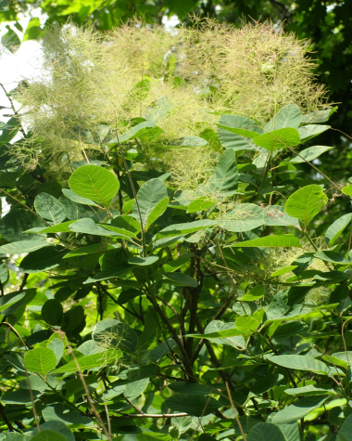

Polygonum bistorta

Botanical Origin.—Polygonum bistorta L. (Engl. – Snakeweed, Bistort; Ukr. – Гірчак зміїний; Rus. – Горец змеиный). Family – Polygonaceae.
Part Used.—Rhizomata Bistortae consist of the dried rhizomes of Polygonum bistorta L., Polygonaceae.
Habitat.—The plant is indigenous to Europe, North America and Asia.
Plant.—The plant is a perennial, 30 cm to 1 m high herb on a thick, serpentine-shaped, somewhat flattened and twisted S- shaped rhizome. The radical, oval leaves grow out of the rhizome to form basal rosette leaves with cordate bases, which are blue-green above and somewhat undulate. The flowering stem terminates in a compact, cylindrical, false spike of flesh-colored flowers without a terminal bud. The pedicle is winged. The flowers consist of 5 sepals, 8 stamens and an ovary with 2 to 3 styles. The flowers are in pairs, one of which is complete, the other only having a rudimentary ovary. Only the latter ripens. The fruit is a three-seeded achene (nutlet). The ripe seeds are small, brown and glossy.
MPM Description.— The rhizome is cylindrical, somewhat flattened, about 1 to 2 cm in thickness, marked with annular or transverse wrinkles, flattened and twisted S-shaped, furnished with numerous rootlets, and folded or bent upon itself, so as to give it the tortuous appearance. Externally it is dark purplish or blackish-brown. The fracture is nearly smooth, reddish or purple, the taste being astringent.
Microscopical Characters.—The rhizome consists of the thin layer of cork. The parenchyma consist of thin-walled meristematic cells. A prominent ring of fibrovascular bundles is oviform. Fibrovascular bundles are collateral, xylem passess toward the centre. The cambium is narrow. Numerous rosette crystals of calcium oxalate occur in parenchyma layer.
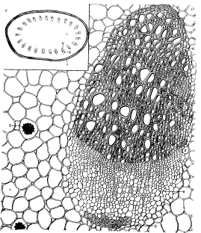

Fig. A – Scheme of a cross section (x10); B–The fragment of cross section in fibrovascular bundles region (x280). 1 – Parenchyma cells; 2 – rosette crystals of calcium oxalate; 3–mechanical cells; 4 – bast; 5 – cambium; 6 – xylem; 7 – cork

Constituents.—Tannins up to 25 % (mainly gallotannin and elagotannin) and gallic acid; cathechins; starch (in the root 30%); silicic acid.
Pharmacological Action. Uses.—MPM is used as astrigent (a binding agent, that contracts organic tissue, reducing secretions or discharges of mucous and fluid from the body). Decoction and extract are used in acute and chronic diarrhea, gastrointestinal inflammations, uterine and haemorrhoidal haemorrhages; stomatitis and gingivitis. MPM is included in the astrigent gastric herbal collections.
Polygonum bistorta
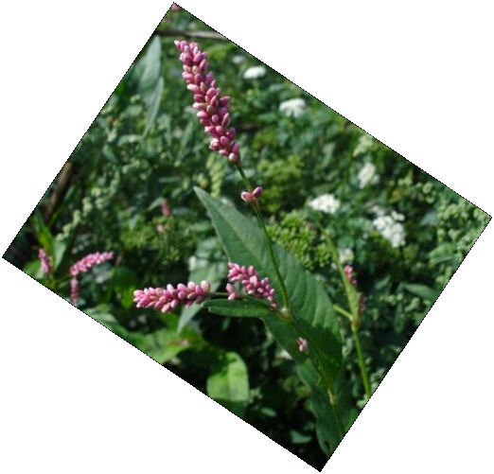

Sanguisorba officinalis

Botanical Origin.—Sanguisorba officinalis L. (Engl. – Great Burnet; Ukr. – Родовик лікарський; Rus. – Кровохлёбка лекарственная). Family –Rosaceae.
Part Used.—Rhizomata et radices Sanquisorbae consist of the dried rhizome and roots of Sanguisorba officinalis L., Rosaceae.
Habitat.—The plant is widespread in the northern, temperate regions of Europe, temperate Asia, and North America.
Plant.—Great Burnet is a perennial herb or semi-rosette shrub with a strong dark brown root that produces thick fibers and a short rhizome. Rhizome long attaining about 20 cm, thickness about 0,5 – 2,5 cm; root attains thickness about 0,3 – 1,5 cm. The stems are erect, angular, glabrous, and bifurcated. The rosette leaves are 20 to 40 cm long and consist of 7 to 15 ovate leaflets, which are cordate at the base and blue-green beneath. There are only a few cauline leaves, which taper towards the top. The composite heads are ovate-oblong, approximately 1 to 2 cm long and consist of 5 to 10 usually androgynous flowers. The calyx has 4 dark red-brown tips, 4 stamens with stiffly patent red filaments and yellow anthers. The smooth, spike-like, quadrangular fruit calyx has 1 carpel and 1 style and is narrowly winged. The fruit is a nut enclosed in the perigone tube.
MPM Description.—Rhizome frequently broken into pieces of varying length and 6 to 20 mm thick, externally surface is smooth, dark-brown, fracture uneven and has radial structure; odour faint; taste astringent.
Microscopic Characters.—Cross section of a rhizome. Cork consists of small cells. Cortex is porous. A zone of cambium consist of several layers of meristematic cells. Phloem and xylem are arranged separately. Parenchyma cells occur between phloem and xylem. Medullary rays are narrow, uniseriate. Aggregate crystals of calcium oxalate and ellipsoidal or oval starch grains occur in parenchyma of pith and cortex. 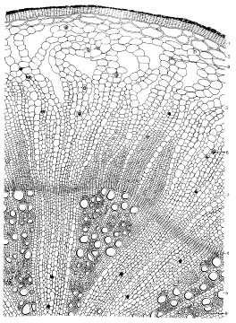
Fig. Fragment of a cross section of Radix Sanquisorbae. 1 – Cork; 2 – phelloderm; 3 – cortex; 4 –cambium; 5 – xylem; 6 – aggregate crystals of calcium oxalate; 7 – medullary rays; 8 – bast fibers; 9 – libriform

Constituents.—Tannins up to 20 % (hydrolyzable gallotannin and elagitannins), gallic and ellagic acids; flavonoids (rutin, flavonoid sulphates); triterpene glycosides; sterols.
Pharmacological Action. Uses.— MPM is used as astrigent in acute and chronic diarrhea, gastrointestinal inflammations, uterine and haemorrhoidal haemorrhages.

